

# JAHANGIRNAGAR UNIVERSITY

# Report on Online Bookshop Management System

Name: Dilara Yasmin

ID: 295

Course Title: Software Engineering

Course code: CSE-355

**Works on:** 1.Exchange book (Sprint-1)

**2.** Discount on purchase (Sprint-2)

**Online bookshop Management system**

**Objectives:** Our Bookshop Management System is an application for students or anybody who wants to buy books .

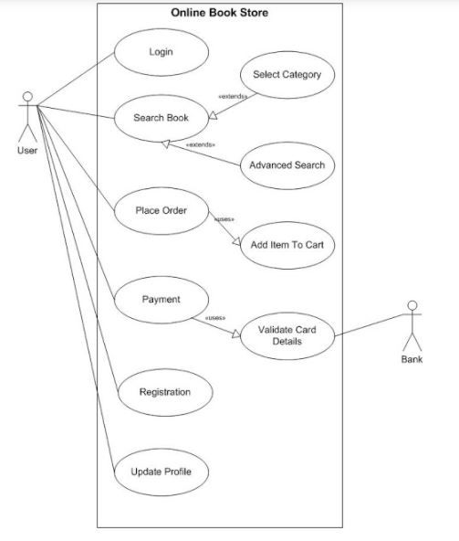

Data flow:

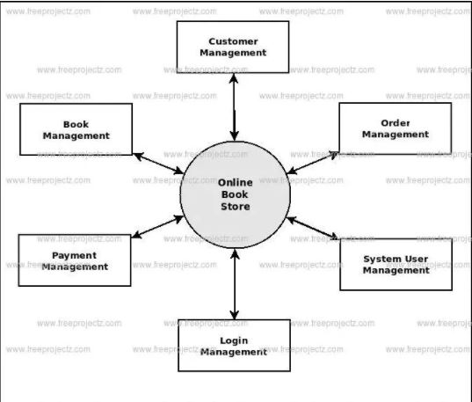

Processing Idea

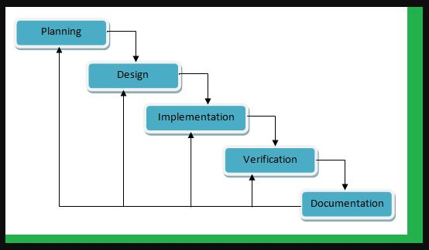

Group members: : Dilara Yasmin (295),Rimi Akter(303),   
Jannatul Mawa (1943), Uzma Hassana Hanian (2521), Tania Rahman (2594)

**Planning**– The Developers gathered relevant information from this online bookshop that will be used for the understanding and development of the system that they need. The Developers interviewed, proposed a project, edit the project if ever there are features that are altered by the Bookshop, and submit final project proposal to them.

**Design**– The Developers now understood the needs of the Bookshop thus; they can now develop the desired system of the Bookstore. The Developers designed the features as per fitted for the Bookstore and all of the features must be functioning, they also had tested the system as per developers and reviewed the overall system if everything is well developed.

Purpose – After making sure that the system is functioning well or if not then maybe some bugs are found sooner, the Developers can now deploy and install the system at the company’s place. Everything is put in place and integrated at this stage

**Works on(1.exchange book and 2.discount)**

**INTRODUCTION**

An online bookstore software projects that acts as a central database containing various books in stock along with their title, author and cost. This project is a website that acts as a central book store. This web project is developed using android studio as The database stores various book related details. A user visiting the website can see a wide range of books arranged in respective categories. The user may select desired book and view its price. The user may even search for specific books on the website. Once the user selects a book , he then has to fill in a form and the book is booked for the user.

**AIM**

The main aim of the project is to exchange book and get discount on purchase and to search and purchase a book online based on title, author and subject. The selected books are displayed in a tabular format and the user can order their books online through credit card payment.

**OPERATIONAL FEASIBILITY**

Operational feasibility is the measure of how well a proposed system solves the problems, and takes advantage of the opportunities identified during scope definition in the time of exchange book and when they get discount.and how it satisfies the requirements identified in the requirements analysis phase of system development. By this project people can exchange book as their desired and get discount by some condition.

SOFTWARE REQUIREMENTS SPECIFICATION

This section includes the Software and hardware requirements for the smooth running of the application. and use some testing and test driven development .there are some code to check out the discount

**DESIGN & PLANNING**

This section consists of the Software Development Life Cycle model. It also contains technical diagrams like the Data Flow Diagram and the Entity Relationship diagram and use MVC architectural pattern.

IMPLEMENTATION DETAILS:

Here we use the android studio app for coding and the main class is .java. Here maintain the **SDLC** formula to implement the project.

**MVC**- **model view controller** architectural pattern is used.

Phase: Exchange book

1. user have to login by email or password
2. check the list which book they want
3. fill up a form for exchange the book with some condition

Phase: discount on purchase

1. User can get discount by their joining time (if they are old customer)

2. Get discount on number of purchase book (if buy more than 10 books)

3. Get discount on second time purchase

Using communication tools:

1. Slack

2. Trello board

3. Github

4.Toggl.

Documentation –The Project is finally presented to the company and at this stage some bugs will be eliminated. The contract then ends and the Developers will give documentation for the system. Manuals will also be submitted to them in order for them to self read how the features of the system will behave.

TESTING AND IMPLEMENTATION:

Unit test- In computer programming, unit testing is a software testing method by which individual units of source code, sets of one or more computer program modules together with associated control data, usage procedures, and operating procedures, are tested to determine whether they are fit for use.

**TDD-test driven development :** Unit testing finds problems early in the development cycle. In test-driven development (TDD), which is frequently used in both extreme programming and scrum, unit tests are created before the code itself is written.

**Benifits :**The goal of unit testing is to isolate each part of the program and show that the individual parts are correct. A unit test provides a strict, written contract that the piece of code must satisfy. As a result, it affords several benefits.

**Integration test**-Integration testing (sometimes called integration and testing, abbreviated I&T) is the phase in software testing in which individual software modules are combined and tested as a group. It occurs after unit testing and before validation testing. Integration testing takes as its input modules that have been unit tested, groups them in larger aggregates, applies tests defined in an integration test plan to those aggregates, and delivers as its output the integrated system ready for system testing.

**Purpose  :** The purpose of integration testing is to verify functional, performance, and reliability requirements placed on major design items.

SOFTWARE VERIFICATION AND VALIDATION:

* Validation: Are we building the right product?
* Verification: Are we building the product right?

**Conclusion:** By this project user can buy books and can exchange books. They also get discount on purchase. Manuals will also be submitted to them in order for them to self read how the features of the system will behave.